Writing custom HTML Helpers for ASP.NET MVC

Subtitle

Ed Charbeneau

First published by Simple Talk Publishing DATE

To indicate that a word is to be included in the Index, please format it as usual, then (or later) select the word(s) and apply Font Color 'Dark Blue' (**assuming that this has not been used in the code examples** **or elsewhere in the text**) using the button as shown below.

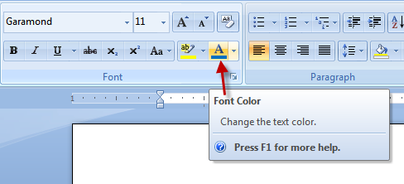

Please do not apply this to words in the code examples.

Text text text text text text text text text text text text text text text text text text text text text text text text text text text.

1. Step step step step step step step step step step step step step step step step step step step step step.

ST Indent under NL for text and graphics under the step.

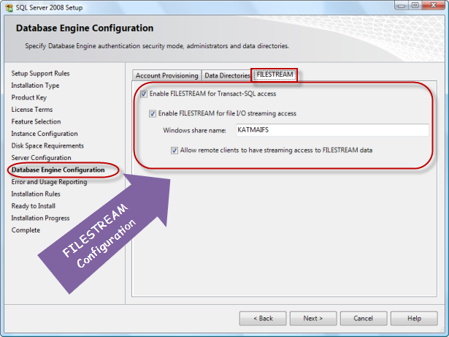

Figure A.1: Caption under NL

1. Next step.

Copyright AUTHOR 2010

ISBN 978-1-XXXXXX-XX-XX

The right of XXXXXX XXXXXX to be identified as the author of this work has been asserted by him in accordance with the Copyright, Designs and Patents Act 1988

All rights reserved. No part of this publication may be reproduced, stored or introduced into a retrieval system, or transmitted, in any form, or by any means (electronic, mechanical, photocopying, recording or otherwise) without the prior written consent of the publisher. Any person who does any unauthorized act in relation to this publication may be liable to criminal prosecution and civil claims for damages.

This book is sold subject to the condition that it shall not, by way of trade or otherwise, be lent, re-sold, hired out, or otherwise circulated without the publisher's prior consent in any form other than which it is published and without a similar condition including this condition being imposed on the subsequent publisher.

Typeset by XXX XXX.

Table of Contents

Chapter 1: Transitioning from webforms 4

Chapter 2: How to begin 4

Chapter 3: Writing a specification 4

Chapter 4: Basic implementation 4

Chapter 5: Fluent configuration 4

Chapter 6: Strongly typed helpers 4

Chapter 7: Final results 4

Chapter 8: Considerations 4

Chapter 1: Transitioning from webforms

Chapter 2: How to begin

Chapter 3: Writing a specification

Chapter 4: Basic implementation

Chapter 5: Basic implementation

Chapter 6: Basic implementation

Chapter 7: Basic implementation

Chapter 8: Basic implementation